Week of 9/3/14
- General
  - Great article by Sal Khan about growth mindsets -- https://www.khanacademy.org/about/blog/post/95208400815/the-learning-myth-why-ill-never-tell-my-son-hes?utm_source=Sailthru&utm_medium=email&utm_term=All%20Teachers&utm_campaign=Sal%20Op-ed%20Email%20%28Teachers%29
  - FREE Site with a nice database of assessment questions (that could also be used in instruction) for math, science, & social studies -- http://www.problem-attic.com/ (If you scroll to the bottom of any subject’s list of topics, there is a section of blended topics & multi-step problems
  - Note-taking strategies – 2 column notes – this is a great way to teach students how to take notes from class AND as they read – see attachment *****
  - NCCAT – if you’ve never gone to an NCCAT workshop, please check out their programs. This is an amazing resource here in NC (free programs; individuals responsible for subs & travel) -- http://www.nccat.org/
  - As you discuss school rules, an interesting article about new policies (esp. including counseling) in LA could spur some good discussions about reasoning behind rules & consequences -- https://newsela.com/articles/laschool-discipline/id/4921/
  - “Working smarter not harder” tips -- http://www.scholastic.com/teachers/top-teaching/2014/08/15-ways-work-smarter-not-harder-school-year
- Science
  - Effects on Napa earthquake -- https://newsela.com/articles/napa-quake/id/4976/
- Social Studies
  - Interesting read about census labeling -- https://newsela.com/articles/census-race/id/4892/
  - Also for ELA – interesting article about English-only debate in US – with a quiz, too - https://newsela.com/articles/english-laws/id/4807/
  - Article that could lead to good discussion of interaction between people, land, etc. -- https://newsela.com/articles/oil-ndnationalpark/id/4993/
- ELA
  - http://www.word-nerd.com/aboutus.aspx Word Nerd -- does have $69 yearly fee, but it looks like there are some great tools here
- Math
  - Definitely check out problem attic – (above) -- http://www.problem-attic.com/
- Encore
  - Tech – robotics – teens building under water robot -- https://newsela.com/articles/underwaterrobot-teens/id/4854/
  - Computers / or Tech class – interesting article about a kids from NC making money with “bitcoin mining” -- https://newsela.com/articles/bitcoin-teen/id/4594/
- Just for fun…
Maybe it feels this way sometimes…
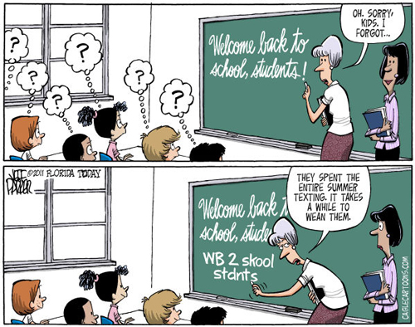
https://www.google.com/search?q=cartoon+about+1st+week+of+school&rlz=1C1UDIB_enUS572US572&espv=2&tbm=isch&tbo=u&source=univ&sa=X&ei=cJcAVL3ADs2uggT2lIKABg&ved=0CCcQ7Ak&biw=1024&bih=653#facrc=_&imgdii=_&imgrc=WF-L8cTCBVkTNM%253A%3BKj5icVft02XNxM%3Bhttp%253A%252F%252Fwww.truthdig.com%252Fimages%252Fcartoonuploads%252Fback2school_500.jpg%3Bhttp%253A%252F%252Fwww.truthdig.com%252Fcartoon%252Fitem%252Fback_to_school_20110813%3B500%3B394

