Week of 9/29/14
- General
  - Site with various differentiated lessons, some tiered by level & some by learning style -- https://sites.google.com/a/nycempowerment.org/implementing-effective-differentiated-instruction/lesson-samples
  - Edmodo – lots of great possibilities for activities, snapshots, etc. -- https://www.edmodo.com/
  - Khan Academy’s Common Core Map – looks pretty helpful for all grade levels -- https://www.khanacademy.org/commoncore/map?utm_source=Sailthru&utm_medium=email&utm_term=All%20Teachers&utm_campaign=Common%20Core%20Map%20%281%2F4%20teacher%20CC%29&utm_content=Final
  - 5 activities to “spark” a student’s love for learning – scroll a little then you’ll see some nice descriptions -- http://www.middleweb.com/17540/five-fun-ways-spark-self-discovery-children/
- Science
  - Student Science website – awesome resource for articles and other resources for discussion, deeper inquiry, etc.; the search tool works great for finding info on specific topics, or you can use the drop-down menus -- https://student.societyforscience.org/
  - (Could overlap in SS when discussing HEI) Great article about human impact on various species & extinction -- https://newsela.com/articles/sixth-mass-extinction/id/5272/
- Social Studies
  - Impact of war on cultural heritage / historical landmarks in Syria -- https://newsela.com/articles/syria-heritage/id/5334/
  - Really interesting article about students protesting a particular school board’s stance on curriculum – could spur great discussion -- https://newsela.com/articles/costudent-protests/id/5366/
- ELA
  - NewsELA – another great, free resource not just for articles but also for quick assessments of students’ reading & comprehension skills -- https://newsela.com/
  - Using music & journaling to develop students’ writing skills -- http://www.eschoolnews.com/2014/09/24/music-student-writing-329/
- Math
  - Khan Academy – if you haven’t used it before, check it out – some great lessons for kids to watch and practice questions -- https://www.khanacademy.org/
- Encore
  - Life Skills – article about eating healthier – reading food labels, what companies are putting in food -- https://newsela.com/articles/junkfood-study/id/5284/
- Just for fun…

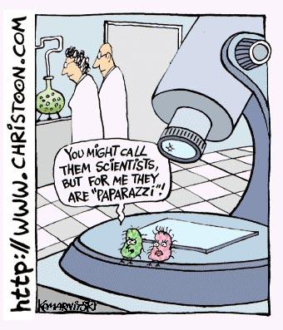
https://www.google.com/search?q=cartoon+about+science&rlz=1C1UDIB_enUS572US572&espv=2&biw=1024&bih=653&tbm=isch&tbo=u&source=univ&sa=X&ei=3FApVKyvCYyONpmhgcgN&ved=0CCAQsAQ#facrc=_&imgdii=_&imgrc=qbUR6OOxMWJrjM%253A%3BE10lTHP6QXoFkM%3Bhttp%253A%252F%252Ffr.toonpool.com%252Fuser%252F617%252Ffiles%252Fpaparazzi_464355.jpg%3Bhttp%253A%252F%252Fgjismyp.wordpress.com%252Fteaching-resources%252Fteaching-cartoons%252F%3B340%3B397

