Week of 9/22/14
- General
  - Complimentary webinar focusing on literacy across curriculums – only 1 hour -- https://www1.gotomeeting.com/register/461966665?_sm_au_=iVVqQ26sWffs1s65
  - Some good classroom apps, specifically Remind & Socrative -- http://www.npr.org/blogs/ed/2014/09/16/347377022/a-is-for-apps-teachers-share-top-digital-tools-of-the-trade
  - Tiering / scaffolding to differentiate instruction & assignments -- (some examples then a template) http://faculty.scf.edu/sharric/lesson5/lesson5diff/tieredtemplate.pdf and nice PPT explaining the reasoning, the process, and samples (attachment)
- Science
  - Concerns about monarch butterfly population dropping -- https://newsela.com/articles/butterfly-gmos/id/5109/
  - Dinosaurs that swam? – pretty cool -- https://newsela.com/articles/swimming-dinosaur/id/5201/
- Social Studies
  - Really interesting piece about China’s reaction to proposed changes in the SAT that would include American historical documents – could really spark some great discussion, maybe a good topic for a class debate -- https://newsela.com/articles/sat-chinesestudents/id/5094/
  - Article about Malala – Pakistani girl shot in 2012 for beliefs about education rights -- https://newsela.com/articles/malala-shooting/id/5208/
  - Controversy over candidates’ residency – could spur some good discussion of why this even matters -- https://newsela.com/articles/senators-hometowns/id/5190/
  - Scottish independence from Great Britain? – great article about the historic vote to remain part of GB – might make for great discussion of pros / cons of independence -- https://newsela.com/articles/scotland-votes/id/5290/
- ELA
  - Next week is banned books week – here are some interesting sites / activities to explore this issue –(downloadable or to be used on smart board – booklet looking at some graphic novels that have been banned with discussion of claims against them) http://cbldf.org/librarian-tools/cbldf-banned-books-week-handbook/?utm_source=Inbox+Issue+-+2014-09-16&utm_medium=Email&utm_campaign=Inbox or fighting censorship http://archives.library.illinois.edu/ncte/about/february.php?utm_source=Inbox+Issue+-+2014-09-16&utm_medium=Email&utm_campaign=Inbox
- Encore
  - Health / PE – fun article about early baseball – maybe it would be fun to play using these old rules & the old language -- https://newsela.com/articles/vintage-baseball/id/5215/
  - Art – great article about cleaning a portrait of Washington – technique, symbolism, all kinds of interesting details -- https://newsela.com/articles/georgewashington-painting/id/5179/
- Just for fun…
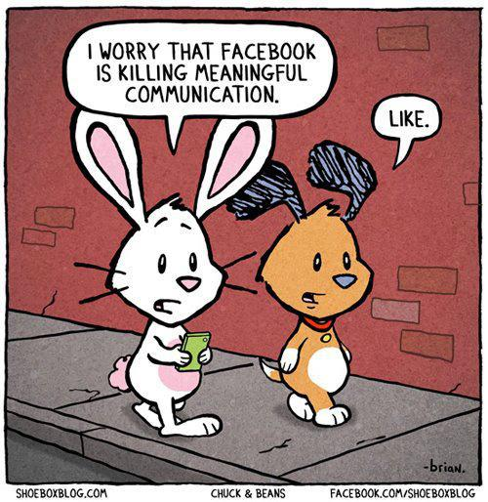
http://media.tumblr.com/tumblr_m8smet2w4V1r2rxth.jpg

