Week of 8/25/14
- General
  - Six skills all kids need – could provide a nice set of over-arching questions to guide instruction in any class -- http://www.edutopia.org/blog/prepare-students-challenges-of-tomorrow-judy-willis
  - Check out this site – looks promising for various classes -- http://www.educatorstechnology.com/
  - Nice interdisciplinary article with history & art – WWI art -- https://newsela.com/articles/wwi-arts/id/4848/
  - Flipped classrooms? If you’ve thought about trying this (and some of you have), here’s a nice article by a teacher who incorporated one flipped lesson into her 7th grade inclusion class (helpful because she outlines her planning & follow-up processes well) -- http://www.middleweb.com/15091/flipped-inclusion-class/
  - Using Minecraft in various classes (I know my girls LOVE this game) -- https://newsela.com/articles/minecraft-schools/id/3796/
  - “embedded assessments in games” – many of you do similar things, but this was a nice blog with some interesting games mentioned) -- http://www.edutopia.org/blog/classroom-game-becomes-embedded-assessment-ross-flatt
- Science
  - The mystery of earthquakes – using science to understand & predict -- https://newsela.com/articles/Wisconsin-earthquakes/id/4833/
  - Ed Technology & Mobile Learning – free chemistry app?? - worth checking out -- http://www.educatorstechnology.com/2014/08/ipad-virtual-chemistry-lab-is-now-free.html?utm_source=feedburner&utm_medium=email&utm_campaign=Feed%3A+educatorstechnology%2FpDkK
- Social Studies
  - Treatment of children at borders -- https://newsela.com/articles/borderchildren-procon/id/4780/
- ELA
  - We have a subscription to TeachingBooks – check it out here -- http://www.teachingbooks.net/
- Math
  - Open Curriculum – free math lesson plans – a colleague shared this after hearing great things at 2 conferences this summer -- http://www.opencurriculum.org/
  - Full text online preview – Intentional Talk: How to Structure & Lead Productive Mathematical Discussions – (really, the whole book is available to preview & looks pretty helpful to me) http://www.stenhouse.com/html/intentional-talk.htm?r=nb140514n
- Encore
  - PE / Healthful Living -- Girls in Little League -- https://newsela.com/articles/littleleague-girls/id/4864/
  - PE / Healthful Living / Computers – importance of using social media wisely, colleges watching athletes’ use of social media -- https://newsela.com/articles/twitter-sports/id/4791/
- Just for fun…

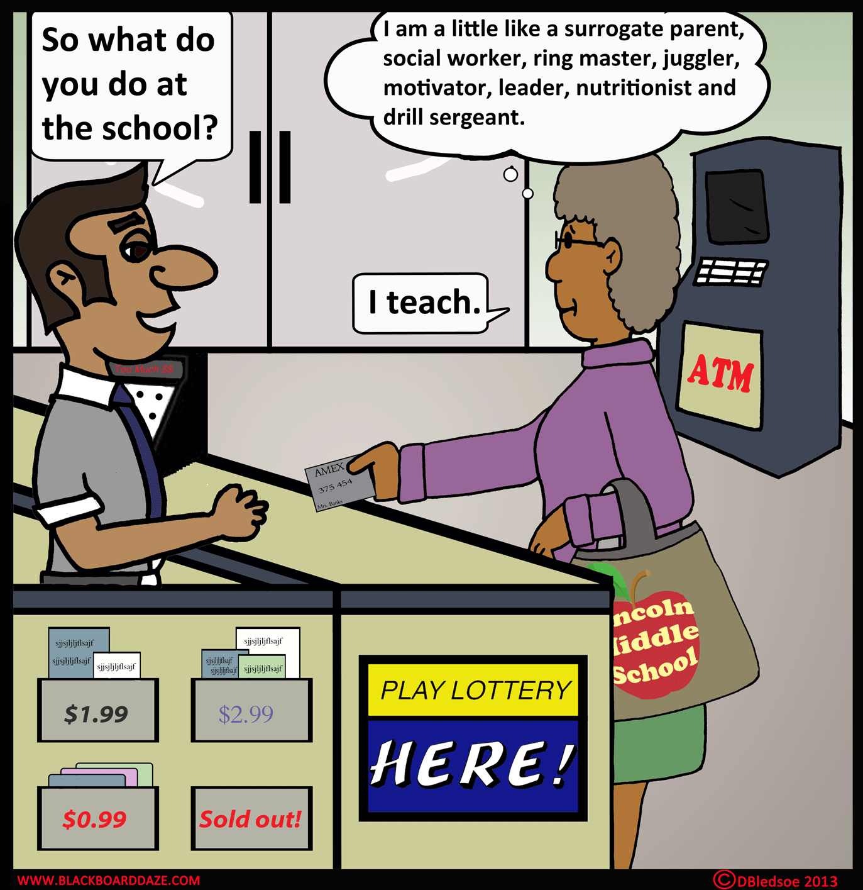
https://blackboarddaze.wordpress.com/category/cartoon-about-school-staff/page/2/

