Week of 5/19/14
- General
  - Flipped classrooms? If you’ve thought about trying this (and some of you have), here’s a nice article by a teacher who incorporated one flipped lesson into her 7th grade inclusion class (helpful because she outlines her planning & follow-up processes well) -- http://www.middleweb.com/15091/flipped-inclusion-class/
  - Tips for end-of-year burnout – these are pretty simple and can be quick & easy (some of you are trying to do this already) -- http://www.edutopia.org/blog/end-of-year-burnout-how-to-finish-stride-maurice-elias
  - Using Minecraft in various classes (I know my girls LOVE this game) -- https://newsela.com/articles/minecraft-schools/id/3796/
  - “embedded assessments in games” – many of you do similar things, but this was a nice blog with some interesting games mentioned) -- http://www.edutopia.org/blog/classroom-game-becomes-embedded-assessment-ross-flatt
  - (listed in ELA section, too, but many of you have students do research projects & might want to check this out -- http://www.middleweb.com/15222/dbq-appoach-research-papers/)
- Science
  - Article about the new roller coaster that could be steepest & fastest ever -- https://newsela.com/articles/wooden-rollercoaster/id/3915/
  - Article about “killer asteroids” -- https://newsela.com/articles/asteroid-crowdsource/id/3957/
- Social Studies
  - Article about kidnapped Nigerian girls -- https://newsela.com/articles/bokoharam-video/id/3998/
  - Obama’s response to missing Nigerian girls -- https://newsela.com/articles/nigeria-kidnapping/id/3926/
  - Possible sunken ship of Columbus -- https://newsela.com/articles/columbus-shipwreck/id/4005/
- ELA
  - Great article with embedded videos of classes where teachers use different strategies to help students manage complex texts – definitely worth watching -- https://www.teachingchannel.org/blog/2014/05/09/video-playlist-text-complexity/
  - Nice overview & explanation of DBQ (document-based question) approach to research papers / projects – http://www.middleweb.com/15222/dbq-appoach-research-papers/
- Math
  - Full text online preview – Intentional Talk: How to Structure & Lead Productive Mathematical Discussions – (really, the whole book is available to preview & looks pretty helpful to me) http://www.stenhouse.com/html/intentional-talk.htm?r=nb140514n
- Encore
  - Health / PE – article about nutrition & school lunch -- https://newsela.com/articles/lunch-standards/id/3951/
  - Technology – article about getting inside Frank Lloyd Wright’s S.C. Johnson’s research tower -- https://newsela.com/articles/scjohnson-building/id/3863/
  - Art – very interesting article about cleaning some of Ancient Athens’ statues -- https://newsela.com/articles/statue-surgery/id/3949/
- Just for fun…
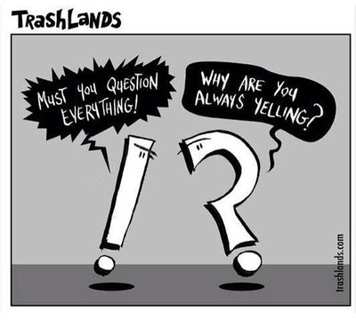https://www.google.com/search?q=grammar+cartoon&rlz=1C1UDIB_enUS572US572&tbm=isch&tbo=u&source=univ&sa=X&ei=Lfl0U-vTNdTNsQSvpYHgDA&ved=0CCcQsAQ&biw=1024&bih=653#facrc=_&imgdii=_&imgrc=gLJ2rnk-2DRWFM%253A%3BIqbEZIovvqbTSM%3Bhttp%253A%252F%252Fmedia-cache-ec0.pinimg.com%252F736x%252F3e%252F83%252F4e%252F3e834e6721f61dba625901c1806ada08.jpg%3Bhttp%253A%252F%252Fwww.pinterest.com%252Frealgrammargirl%252Fgrammar-girl-cartoons%252F%3B400%3B360

