Week of 3/3/14
- General
  - In talking with a few teachers this week, several questions have come up regarding how we can motivate our students to care more about their own learning (this is certainly a never-ending question, in my experience), so I wanted to share a blog I saw that makes some suggestions on creating a culture of learning. http://www.edutopia.org/blog/promoting-a-culture-of-learning-terry-heick
The writer includes a visual demonstrating the “gradual release of responsibility” http://www.edutopia.org/blog/promoting-a-culture-of-learning-terry-heick
  - Student-led conferencing – If you’ve never tried this and would like to know more about it, please talk to me. We used to do this at North Davidson Middle with our team, and it was wonderful – here’s a quick blog about it: http://www.stltoday.com/suburban-journals/stcharles/education/teachers-switching-format-of-parent-conferences/article_6441df3e-b94a-5898-87b3-e9b8c66422db.html

- Interdisciplinary planning
  - Using the Iditarod in math, ELA, and possibly SS
  - https://www.teachingchannel.org/blog/2014/02/20/iditarod-lesson-ideas/
(the above link has some great overviews and links to lesson plans)
- Science / Social Studies – tool to assist students as they read passages
  - Online – looks like someone has a textbook online with review, quizzes, etc. Definitely worth checking out - https://sites.google.com/a/stanlycountyschools.org/tommythompson/science/msl-prep-resources (6th grade)

- Math

  - Math madness contest through TenMarks -- https://www.tenmarks.com/login?mkt_tok=3RkMMJWWfF9wsRokuqjLZKXonjHpfsX56%2B8tWqKzhYkz2EFye%2BLIHETpodcMTstnPa%2BTFAwTG5toziV8R7jMK81rz98QWxbj

- ELA
  - Vocabulary instruction – preview the book Word Nerds online at http://www.stenhouse.com/html/word-nerds.htm?r=nb140226n
There are some strategies in there I’ve used before but also several that look a little different. (You can see the PDF of the whole book for free.)

- Professional Development opportunities (some free, some, not so much – sorry)

  - https://mail.google.com/mail/u/0/#inbox/14469908a1f734ed
  - http://www.learnnc.org/lp/pages/7698

- Interesting articles
  - Learner-centered classrooms - http://www.middleweb.com/13588/inclusion-classrooms-must-learner-centered/
  - Instructional Rounds – sounds like an interesting way to reflect and be a little innovative in growing our own instructional methods -- http://www.edutopia.org/blog/instructional-rounds-distrct-wide-benefits-elena-aguilar

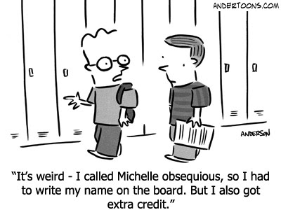
(borrowed from Accomplished Teacher by SmartBrief)

