Week of 10/6/14
- General
  - Any of you who are trying some flipped lessons or those of you trying to use more tech but feel limited by the amount of computers / ipads / whatever device – this workshop looks interesting -- http://www.etechcampus.com/event-detail/39
  - Great site with videos, text exemplars, all sorts of good things (thanks, Mr. Joyce) -- http://www.watchknowlearn.org/
  - (email already sent about this, but it’s definitely something to read) – documents from DPI’s site based on info from MetaMetrics study that should help to clarify what students at level 1,2,3,4,5 are able to do, etc. and with a chart outlining lexile / quantile ranges for those 5 levels at grades 3 – 8 plus Math I and English II -- http://www.ncpublicschools.org/accountability/lexilequantileinfo
  - Great site for making quizzes (competition style – I’ll show you some asap) OR you can use quizzes that are already there – really fun -- https://create.kahoot.it/#login?next – here’s a link to a video of it being played in a classroom (best thing, kids can use phones, ipads, or computers while questions are on the smart board) -- http://blog.getkahoot.com/post/47536212854/a-year-9-class-at-ratton-school-in-eastbourne-are
  - Great activities from Mindful Achievement workshop through PTEC to activate both sides of the brain – they mention Brain Gym (but all I’m finding costs), so here’s a link to a document explaining some of these activities -- http://sspw.dpi.wi.gov/files/sspw/pdf/sascevanshandouts.pdf
- Science
- Social Studies
  - (overlaps with ELA) – storytelling as a way to share histories -- https://newsela.com/articles/campfire-stories/id/5349/
  - Great current event article about Secret Service director’s resignation -- https://newsela.com/articles/pierson-resignation/id/5457/
  - (overlaps with Health / PE) – death rates cut in half -- https://newsela.com/articles/child-mortality/id/5262/
  - Younger men (really just teenagers) fighting in the war in Syria -- https://newsela.com/articles/child-rebels/id/5282/
- ELA
  - (put this in Encore, too, BUT great pro / con article) the organization of the article gives a great example of pro / con debates, persuasive language, etc. -- https://newsela.com/articles/healthylunch-procon/id/5197/
  - Another nice site Mr. Joyce found with lots of videos, lessons, activities, etc. -- http://www.ereadingworksheets.com/
- Math
- Encore
  - Great pro / con article about regulations & school lunches -- https://newsela.com/articles/healthylunch-procon/id/5197/
  - Health / PE – (overlaps with SS) -- death rates cut in half throughout the world -- https://newsela.com/articles/child-mortality/id/5262/
- Just for fun…
Anyone feel this way?

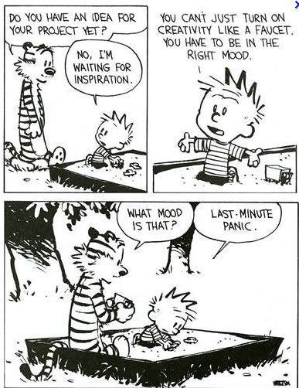https://www.google.com/search?q=welcome+fall+cartoon&rlz=1C1UDIB_enUS572US572&espv=2&biw=1024&bih=610&tbm=isch&tbo=u&source=univ&sa=X&ei=ApsuVP_tMoqTyATV1oKoDw&ved=0CB0QsAQ#facrc=_&imgdii=_&imgrc=TqfB0mS_h55tVM%253A%3B8TMeJ7B58VavOM%3Bhttp%253A%252F%252Fwww.wcpf12.vanessaalander.com%252Fwp-content%252Fuploads%252F2012%252F09%252Fcreativity-cartoon.png%3Bhttp%253A%252F%252Fwww.wcpf12.vanessaalander.com%252F%3B387%3B502

