Week of 10/27/14
- General
  - Kahoot – if you’ve tried it with your classes, let me know how it went; one teacher shared that at the end of the game, there IS an option to print game results, and you can download them later. Scroll towards the bottom of this page for details -- https://getkahoot.com/tutorials/Kahoot_Tutorials.pdf. There are some great ideas on this page about using Kahoot to introduce new topics, letting students create their own, etc.
  - Nice, thought-provoking blog about what it means to be a “connected educator” with some good tips and questions -- http://www.middleweb.com/18269/common-core-demands-connected-educators/?utm_source=Inbox+Issue+-+2014-10-21&utm_medium=Email&utm_campaign=Inbox
  - Pretty interesting study about standing at desks v. sitting & improved attention & focus – I know we don’t have standing desks, but I’ve seen many teachers let students stand at counters & take notes / work during class -- http://blogs.kqed.org/mindshift/2014/10/how-standing-desks-can-help-students-focus-in-the-classroom/
  - Classroom management – techniques for quieting a class – some good, age-appropriate tips -- http://www.edutopia.org/blog/30-techniques-quiet-noisy-class-todd-finley
  - Nice blog discussing 3 myths of differentiating instruction with some helpful suggestions & tools -- http://www.edutopia.org/blog/differentiated-instruction-myth-no-time-john-mccarthy
  - A few of you are working on flipped classrooms, so I thought you’d like this article & that some of these tips could be useful -- http://www.edutopia.org/blog/fliperentiated-instruction-create-customizable-classroom-joe-hirsch
- Science
  - Article about Nigeria’s success in fighting Ebola virus – https://newsela.com/articles/Nigeria-ebolafree/id/5693/
- Social Studies
  - Really great suggestions for media literacy and breaking down political campaign ads – there is a nice list of questions for students to answer about the ads plus links to fact checking sites – could be a great tool -- http://www.middleweb.com/18374/campaign-ads-politicians-permission-lie/
  - Overlaps with ELA & Art – really nice article about an artist from SC who reinterprets the rebel flag in his art – nice discussion of imagery & symbolism -- https://newsela.com/articles/confederateflag-art/id/5564/
  - Article about China’s ancient Buddhist caves -- https://newsela.com/articles/temple-tourists/id/5488/
  - Could overlap with math – article about population growth -- https://newsela.com/articles/AsianAmericans-south/id/5549/
- ELA
  - Overlaps with SS & Art -- – really nice article about an artist from SC who reinterprets the rebel flag in his art – nice discussion of imagery & symbolism -- https://newsela.com/articles/confederateflag-art/id/5564/
  - Example lesson with informational texts & using the “3-2-1” strategy for quick discussion -- http://www.readwritethink.org/classroom-resources/lesson-plans/reading-informational-texts-using-951.html?tab=4#tabs
- Math
  - Overlaps with SS but great numbers here about population growth -- https://newsela.com/articles/AsianAmericans-south/id/5549/
- Encore
  - Band – really interesting article about Cuba’s music – the difficulty of keeping instruments in tune, the limited access to imported instruments, etc -- https://newsela.com/articles/cuba-violins/id/5668/
  - Technology – variety of uses for drones, from assessing damages for insurance purposes to filming sports events – pretty cool -- https://newsela.com/articles/drones-commercial/id/5676/
  - Art – overlaps with ELA & SS -- – really nice article about an artist from SC who reinterprets the rebel flag in his art – nice discussion of imagery & symbolism -- https://newsela.com/articles/confederateflag-art/id/5564/
  - Health / PE – great Pro / Con article about issues NFL’s response to domestic violence issues and media’s role, even controversy over mascots -- https://newsela.com/articles/nfl-procon/id/5600/
- Just for fun…
Definitely true for many of us.

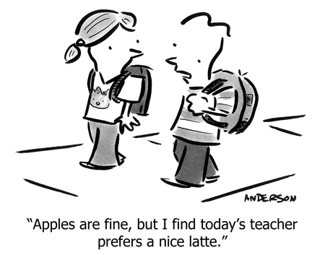
http://cdn.andertoons.com/cartoon-blog/2010/09/teacher-9-10-small.jpg

