Week of 10/20/14
- General
  - Check out this online preview for a book with TONS of 3-Minute Motivators from Stenhouse Publishing – might be worth trying! -- http://www.stenhouse.com/html/3-minute-motivators-revised-edition.htm?r=nb141010n
  - May be a bit long, but there are some great ideas here about reflecting on our practice & some nice tips -- http://www.middleweb.com/18174/aha-moments-better-teaching/
  - A few of you have mentioned wanting to incorporate some project-based learning – here’s a nice article with a few questions to help guide planning -- http://www.edutopia.org/blog/avoiding-flop-guide-project-inquiry-joshua-block
  - Great pro / con article about using social media as a tool in education – this could be a great model for some pro / con writing in class, too, about all sorts of topics -- http://www.pbs.org/newshour/updates/social-media-valuable-tool-teachers/
- Science
  - Article about the Texas nurse who is confirmed to have Ebola – some good introductory details about the spread & prevention of this disease -- https://newsela.com/articles/ebola-nurse/id/5592/
- Social Studies
  - Two teens who won Nobel Peace Prize – check with level on this one because the info regarding sexual abuse is a little more detailed in upper level lexile versions -- https://newsela.com/articles/Nobel-peacewinner/id/5588/
  - Nice article about using mediators in Ferguson (many of you use ChannelOne – this has been a topic there, too) -- https://newsela.com/articles/ferguson-agency/id/5625/
  - (may be a little late, but…) interesting article about a 600-year-old Polynesian canoe & insights scientists are getting into this ancient culture -- https://newsela.com/articles/polynesian-canoe/id/5436/
- ELA
  - Great post with a nice example of how to teach students “new literacy” – very helpful guided steps -- http://learning.blogs.nytimes.com/2014/10/08/guest-post-practical-tools-for-teaching-news-literacy/?_php=true&_type=blogs&module=BlogPost-Title&version=Blog%20Main&contentCollection=U.S.&action=Click&pgtype=Blogs&region=Body&_r=0
- Math
  - If you haven’t before, check out National Council of Teachers of Mathematics (NCTM) site – here’s a link to their lessons & resources page – (if you click “middle” there are some great links to lessons on stats & prob right now, and scroll to the bottom for a “problem of the week”) -- http://www.nctm.org/resources/default.aspx?id=230
- Encore
  - Health / PE – great article about sports injuries (concussions, repetitive use) and heat stroke -- https://newsela.com/articles/heatstroke-students/id/5513/
- Just for fun…
(especially funny -- ok, maybe a little sad – considering some of the things we’ve heard from students)
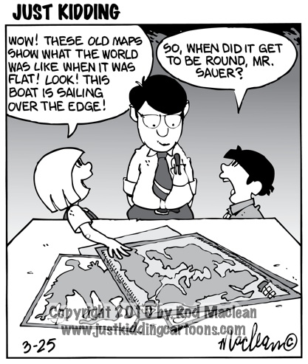
http://www.justkiddingcartoons.com/i/Cartoons/Cartoon_306wtmk.jpg

