Week of 10/13/14
- General
  - Misleading title about daydreaming but interesting article about multitasking (5 tips to help manage all the tasks instead of multi-tasking) – tips 2, 4, & 5 could be helpful in a classroom -- http://blogs.kqed.org/mindshift/2014/10/why-daydreaming-is-critical-to-effective-learning/
  - Nice post about memory building & some suggested activities -- http://www.edutopia.org/rote-learning-benefits
  - Brainu.org – nice site with all sorts of research info PLUS lessons for various classes -- http://brainu.org/resources/MNSTDS
- Science
  - Really cool article about using 3-D printers to make prosthetic limbs (overlaps with tech class, but SO worth it) – students would probably really respond to this one -- https://newsela.com/articles/3D-limbs/id/5466/
  - Article about spread of Ebola & mistreatment of Liberians related to it -- https://newsela.com/articles/texas-ebola/id/5470/ another article about Duncan’s death (1st man diagnosed with Ebola in US) -- https://newsela.com/articles/duncan-death/id/5533/
  - Effects of climate change relating to walruses -- https://newsela.com/articles/walrus-ashore/id/5478/
  - Article about physics team who discovered LED lights receiving Nobel Prize --https://newsela.com/articles/physics-nobel/id/5527/
- Social Studies
  - Article about states voting on proposals for increasing minimum wage -- https://newsela.com/articles/politics-minimumwage/id/5386/
  - Great article to use when discussing Islam – deals with Hajj & kids taking selfies during this pilgrimage – pretty interesting -- https://newsela.com/articles/hightech-hajj/id/5486/
  - Treasures from ancient Peru on display in Texas -- https://newsela.com/articles/peru-gold/id/5437/
  - Another great PRO / CON article – should US send weapons to Ukraine? -- https://newsela.com/articles/ukraineaid-procon/id/5421/
- ELA
  - Writing as therapy – article about writing program for teens in jail -- https://newsela.com/articles/juvenilehall-writers/id/5430/
- Math
- Encore
  - Tech – awesome article about using 3-D printers to make prosthetic limbs (overlaps with science a little, but…) -- https://newsela.com/articles/3D-limbs/id/5466/
  - Art – blending arts with core subjects – describes a program in Prince George County -- http://www.gazette.net/article/20141007/NEWS/141009472/1145/prince-george-x2019-s-school-pilot-program-infuses-arts-with-core&template=gazette
- Just for fun…
I know I’ve felt this from a few students….honestly, I’ve felt it myself!

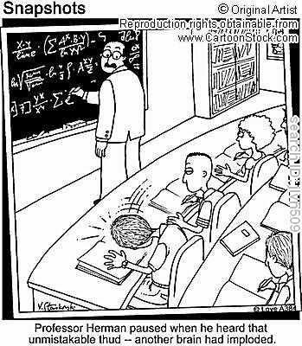
https://www.google.com/search?q=accomplished+teacher+cartoon&rlz=1C1UDIB_enUS572US572&espv=2&biw=1024&bih=653&tbm=isch&tbo=u&source=univ&sa=X&ei=Lho4VOnPOa-HsQSv6IGgAg&ved=0CB0QsAQ#facrc=_&imgdii=_&imgrc=ZCC-RJbMxwaKrM%253A%3BO8Pz9Zgx_BitHM%3Bhttp%253A%252F%252Fbrookechristensen.files.wordpress.com%252F2010%252F10%252Fteach.jpg%3Bhttp%253A%252F%252Fbrookechristensen.wordpress.com%252Fcategory%252Fbook%252F%3B349%3B400

