Tips for using Quotations & Making References in Essays about Literature

Keys to effectively using references and quotes:
- Distinguish your own thoughts from those of the author.
  - Readers need to be able to distinguish when your ideas have stopped and the author's have begun.
  - Arrange your sentences to make the distinctions clear.
  - Consider the following example:
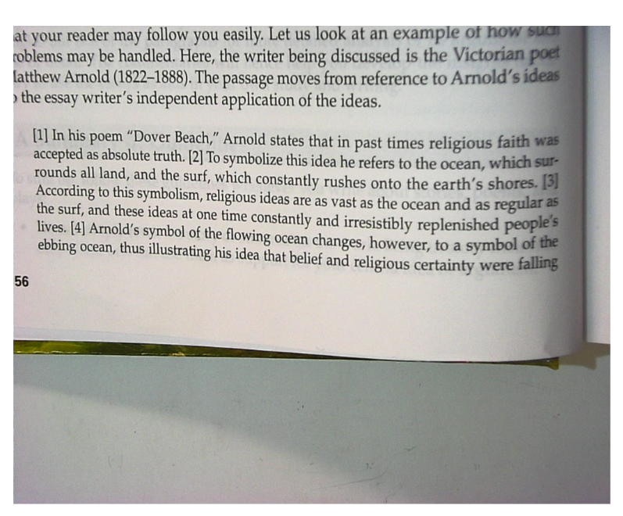
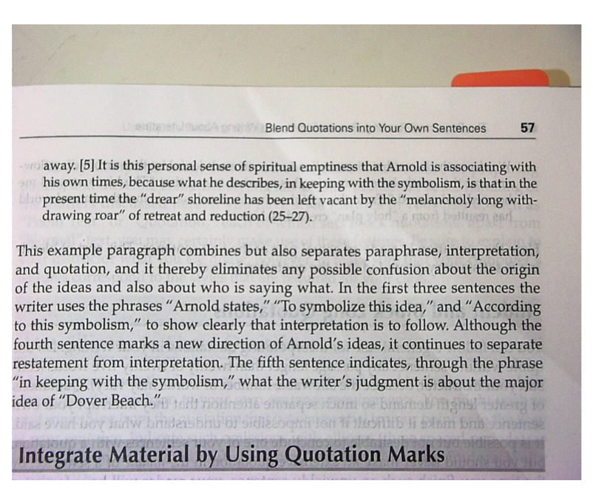
- VARYING your sentence structure can also be very helpful.
  - Consider the following examples to see some different sentence patterns which more effectively use quotes.
  - Remember to NEVER simply DROP IN quotes!
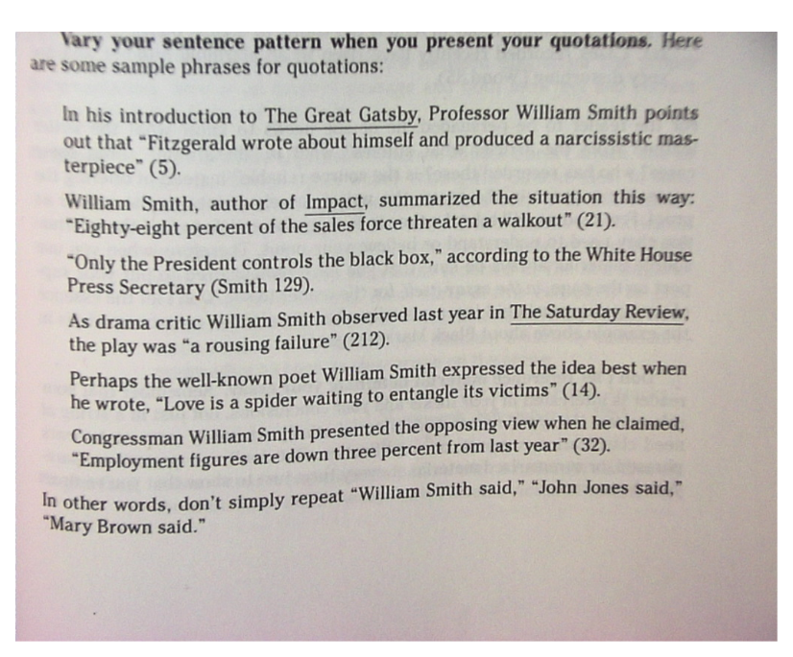
- Integrate material by using quotation marks correctly.
  - Using short quotations to illustrate & reinforce your ideas can help solve the problem which often happens in tip 1.
  - Be sure to use " " and parenthetical citations.
  - Lines of poetry are separated with / as we have done with some of our reading.
  - Consider the following example:
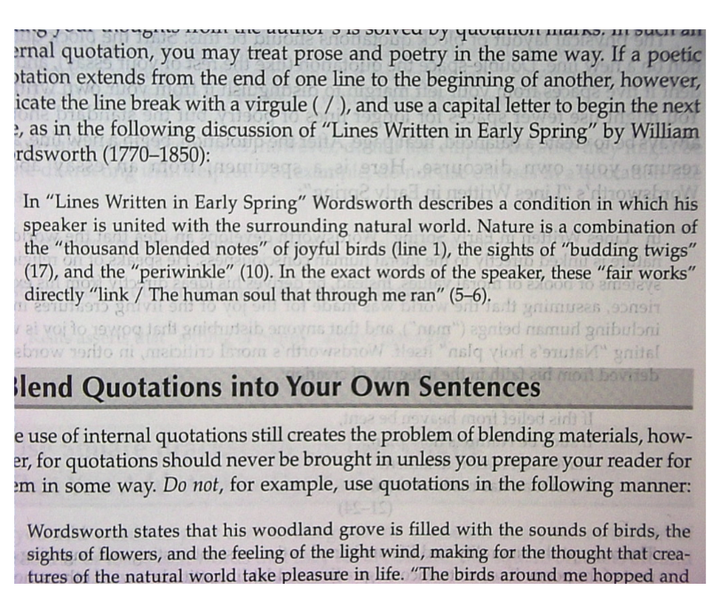
- Blend quotations into your own sentences.
  - Be sure to carefully blend quotations so that your thoughts are still clearly separated from the author's.
  - DO NOT simply "drop in" your quotes in the following way: Wordsworth states that his woodland grove is filled with the sounds of birds, the sights of flowers, and the feeling of the light wind, making for the thought that creatures of the natural world take pleasure in life. "The birds around me hopped and played."
  - The ABOVE example is PROBLEMATIC because you MUST prepare the reader for the quote and have the quote tied to your sentence. Consider the revision:
Wordsworth claims that his woodland scene is made joyful by the surrounding flowers and the gentle breeze, causing his speaker to say that "The birds around me hopped and played" (ll. 13). From this joyful scene, his conclusion is that the natural world has resulted from a "holy plan" (ll. 22) in nature.
- Indent and block long quotations.
  - Most importantly, AVOID LONG QUOTATIONS.
  - Typically, people only use them to take up space, and you could more effectively blend the necessary portions in as discussed in last tip.
  - Follow this general rule: don't quote a sentence longer than 20 or 25 words.
  - If a long quote is ABSOLUTELY NECESSARY, follow these steps:
    - block quotation begins a new line,
    - double-space just like the rest of your essay, &
    - double-tab the entire quote to distinguish it from your own writing.
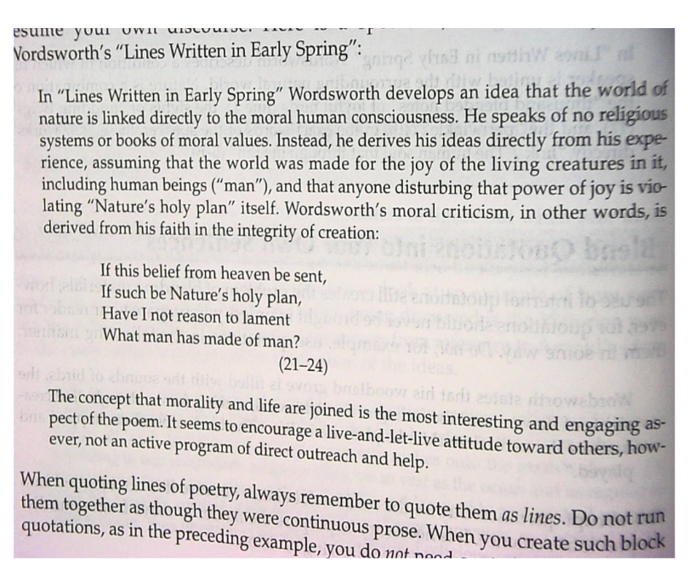
- Use ellipses to show omissions.
  - Since you are trying to create a nice flow in your writing, sometimes you need to omit words from the quote to help the quote fit your sentence structure.
  - Indicate omissions accordingly -- use 3 ... when leaving out part of a sentence and use 4 .... when leaving out more than a sentence.
  - With very brief quotations, ellipses are not necessary because they tend to become distracting.
  - Do NOT do this: "Keats asserts that "... a thing of beauty..." always gives joy.
  - INSTEAD simply do this: "Keats asserts that "a thing of beauty" (ll. __) always gives joy.
- Use brackets to enclose words you add within quotations.
  - Sometimes additions are necessary to make the quote fit within your sentence structure.
  - Sometimes you need to change a pronoun to make it fit your sentence.
  - Here's an example:

In "Lines Written in Early Spring," Wordsworth refers to a past experience of extreme happiness, in which Nature seemed to "link / The Human soul that through ... [him] ran" (ll. 5-6). He is describing a state of mystical awareness in which "pleasant thoughts / Bring [him] sad thoughts" (ll. 3-4) and make him "lament" moral and political cruelty.

- Do not over quote.
  - You are being judged on your thoughts and on the continuity and development of your essay.
  - It is important to use textual support, but there is a fine balance to be found.
  - If your essay has too many quotes just strung together, how much thinking have you actually shown?
  - The key is to create your own discussion and use appropriate examples to connect your thought to the text.

- Preserve the spellings in your sources.
  - Your principle is to duplicate everything exactly as you find it.
  - Changing the spelling can greatly impact the meaning, never mind the fact that it is an unethical use of quotes.
  - You MAY clarify the confusing word within brackets, as in the following: In 1714, fencing was considered a "Gentlemany [i.e., gentlemanly] subject."
  - Use the word sic (Latin for thus, meaning "It is this way in the text") in brackets immediately after the problematic word or obvious mistake: He was just "finning [sic] his way back to health" when the disaster struck.
- When using evidence from multiple sources, use the first word of the Works Cited entry to clarify which source you are using. This should either happen within the text of your sentence or in the parenthetical citation.

